Mural Project Commission
April 2023

Future Now is an initiative from the College of Social Sciences and Arts at Sheffield Hallam University. As part of Future Now we are looking at the environment the college is situated in, we are also working with the Transport Interchange and SYMCA in order to improve the environment of the Interchange. This has led to considering our spaces that border with the interchange and considering the positive impact we can have.

The Transport Interchange is a significant site for visitors entering the city and moving through the space to other important city destinations. This intervention will positively enhance the environment in this neglected area of the city centre.

This project will highlight the creativity of Sheffield Hallam Alumni, alongside the environmental improvement.

Who can take part?
Sheffield Hallam University Alumni, from any course can apply for this commission.
Is there a theme?
We would like the artwork to compliment the site and have a conceptual link to the surrounding area. We are suggesting themes of ‘connections’ however welcome other ideas. The selection will be made on the basis of the best artwork for each site.
Can I apply for both sites?
Yes, we welcome applications for either, or both sites.
Sites:
Site 1 would be the walkway between the station and the interchange. These walls belong to SHU and the walkway itself belongs to SYMCA. This walkway can feel dark and unloved and artwork placed here could make a difference to how the space feels and the visitor experience.
When walking from the train station to the interchange, it is the left hand wall. Marked in yellow below.
Approximate measurements — 30m long x 2.9m at its highest point.
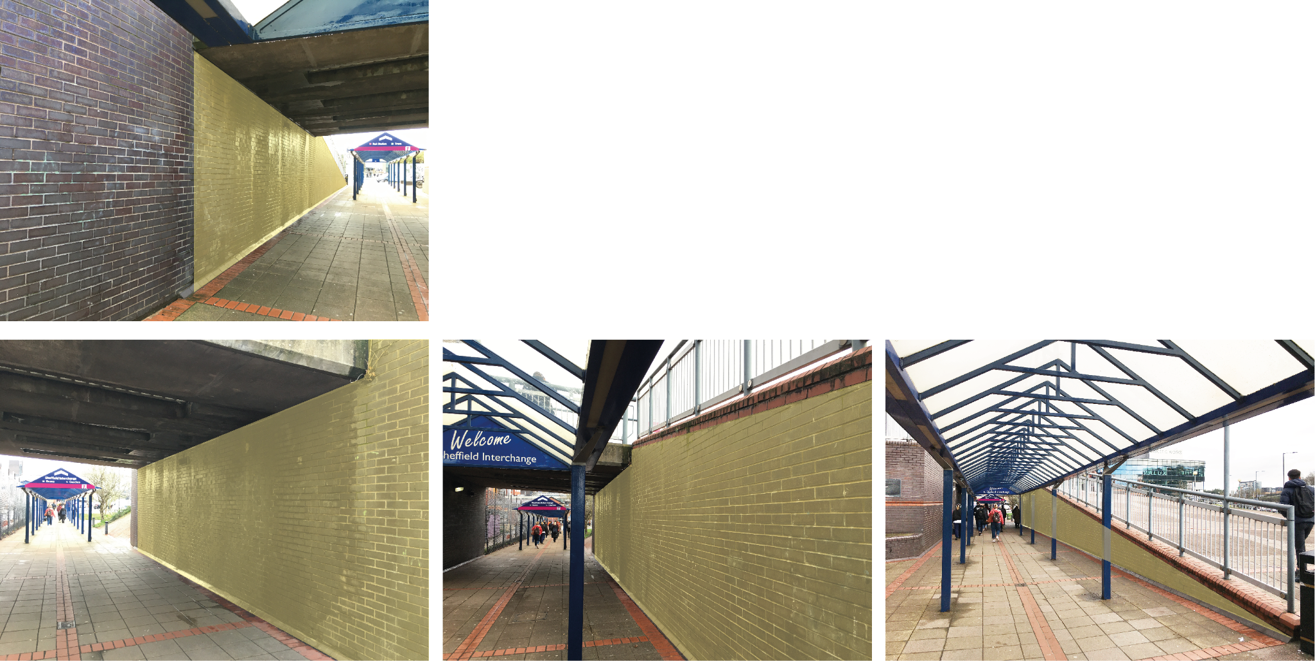

Site 2 would be the SHU car park concrete wall on Pond Street. This site is less complex but is highly visible and can brighten up Pond Street for pedestrians and bus passengers.
The whole of this concrete curved wall.
Approximate measurements — 17.2m long x 1.9m at its highest point.
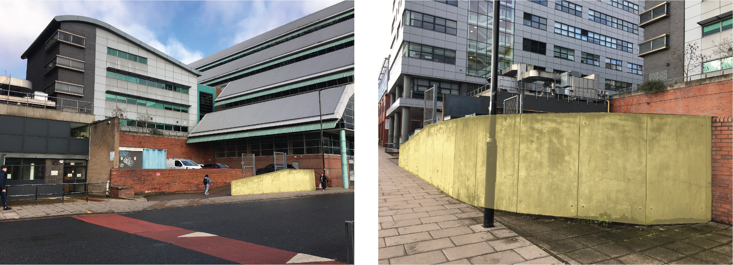

Commission fees
Site 1: £3600 artist fee plus materials
Site 2: £2700 artist fee plus materials

Both sites will be cleaned prior to installation. You will be working with the SHU estates team to support the safety of your installation. You are responsible for any other pre installation preparation, as required.

Commissioning process and requirements
Requirements:
- Artist to supply a CV including relevant experience of other outdoor work
Please include the course and year of graduation from SHU and any relevant portfolio of professional work.
- Your proposal for the site including:
A statement (max 300 words) to explain your idea.
Scale drawings/images
Proposed application method and approximate cost of materials and wall preparation
Any support requirements

Submission details for applications:
Please send your application by email to p.bowman@shu.ac.uk
Please keep files below 10mb

Selection process:
The selection of artwork will be made by a panel of representatives from SHU and SYMCA. Following a shortlisting process there will be an informal interview and opportunity to present your proposal and ask questions.
Timeline:
May 2023 — Commission launch
Wednesday 7th June 17.00 — Closing Date
From July 2023 — Installation

IP of the work will be retained by the artist but SYMCA/SHU will be able to use images for promotion purposes.
Contracts will be signed following the selection process.
Unsuccessful applicants will be contacted by email.

Any queries please contact Pam Bowman p.bowman@shu.ac.uk

Terms & Conditions
USING YOUR ARTWORK
1. We (Sheffield Hallam University) thank You (a participant in the Future Now Mural Commission) for your willingness to share with us your artwork (“Artwork”).
2. You confirm that the Artwork is created by You and that no one else can claim to be its author.
3. You allow us to keep your Artwork, if selected for the commission, so we can use, publish, reproduce it. We may also use your Artwork in our educational activities.
4. We will aim to publicly credit you, wherever this is reasonably possible, as the author of the Artwork.
5. Allowing us to use your Artwork does not prevent you from using a copy of the same Artwork for your own purposes wherever and whenever you want to, including if you want to commercialise it.
6. If you are happy with this statement, please fill in your full name and address where indicated and sign or tick the box (for electronic submission).

